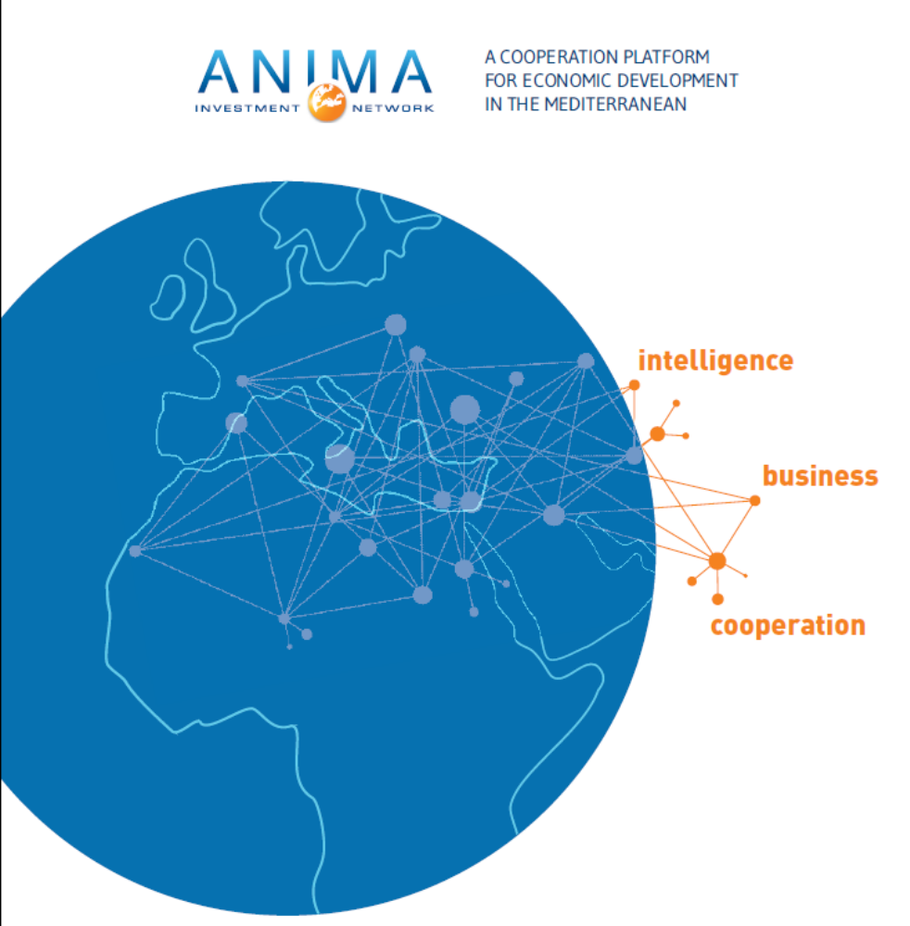

MEMBERSHIP FILE
YEAR 2020

Working towards a shared and sustainable economic development in the Mediterranean, Europe and Africa
ANIMA Investment Network brings together people working for the economic development of the Mediterranean. The ANIMA network gathers 80 organisations and operates within 18 countries in the Euro-Mediterranean zone and comprises national and regional investment promotion agencies, business federations, innovation clusters, financial investors and research institutes from the region.
ANIMA’s objective is to contribute to the continued improvement of the business and investment climate, as well as encourage shared and sustainable economic development between the Mediterranean, Europe and Africa. In order to do this, ANIMA offers its partners expertise and economic intelligence tools aimed at improving the attractiveness and competitiveness of territories, the development of economic exchanges and cooperation, and business and investment internationalisation between the Mediterranean, Europe and Africa.
The participants in ANIMA’s activities include companies, investors, public and private agencies, international organisations and support structures for both business and territorial development.
Become a member of ANIMA Investment Network
Being a member of ANIMA allows you to become part of an international network comprising influential and active members across the Mediterranean, access to a recognised expertise, resources and key contacts, and access to personalised support to help you develop your organisation in the Mediterranean, Europe and Africa, and promote your organisation across the network.

The membership to the ANIMA network is open to any type of organisation and can be subscribed at any time in the year. It is valid from the 1st January to the 31st December of the current year, and gives access to the following benefits.
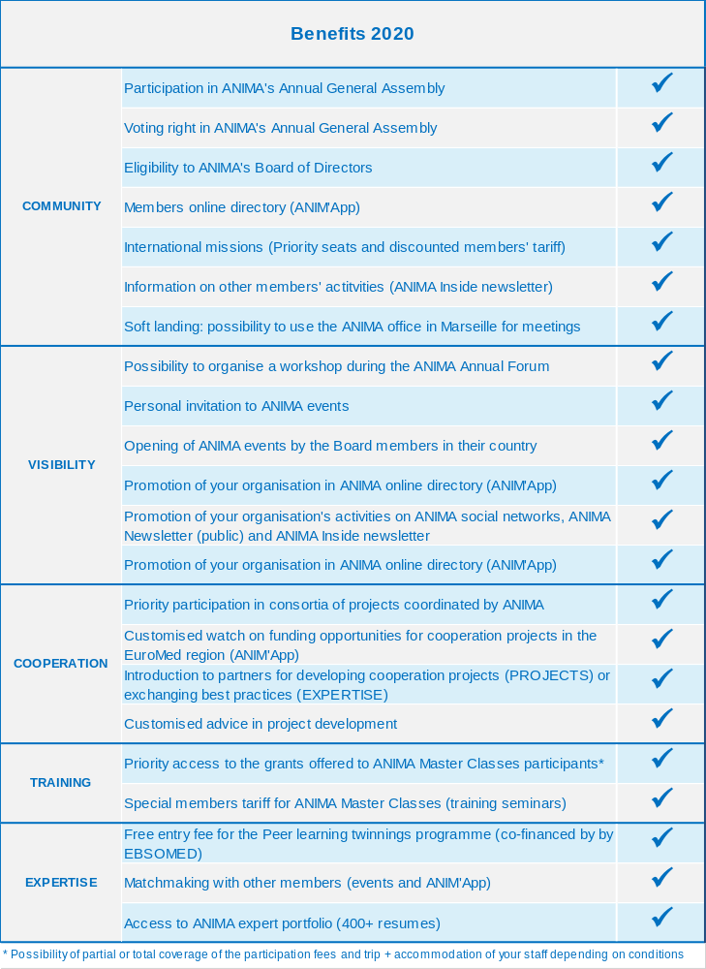

ANIMA Network 2020 membership form
I undersigned (first name, last name):
Position:
Acting in the name of (organisation):
Legal status of the organisation:
Postal address: |  | Country:
Telephone: | Fax : |  | Mail:
I hereby confirm that I wish to [join/ renew my membership to]* the ANIMA Network as:
Membership category chosen | Annual Fee
Membership category chosen | Non Profit org. | Profit Making org.
DISCOVERY MEMBERSHIP (1st Year) | 1 000 € | 2 000 €

Method of payment (to be done once the membership approved by the Board)
By cheque (only in Euros) payable to ANIMA Investment Network
By bank transfer to the following account:
Bank code Branch code Account number RIB key
30056 00196 01962004959 77
IBAN: FR76 3005 6001 9601 9620 0495 977
BIC/SWIFT code: CCFRFRPP
Domiciliation: ANIMA, HSBC, Place de la Joliette, 13002 Marseille
Date and references of the cheque or money transfer:
The final registration of your membership is subject to the validation of the ANIMA Investment Network’s Board and to the payment of your membership fee.
Other requested documents:
- Statutes (association) or corporate registration references (company)
- Questionnaire on your expectations

I authorise ANIMA to publish my organisation profile in the ANIMA Network’s members directory which is distributed to the network members.
On (date) at (location)
Signature 

Please return this form and the requested documents to:
ANIMA Investment Network, 11bis rue Saint-Ferréol, 13001 Marseille (France)
FAX: +33(0)4 96 11 67 61 | EMAIL: manon.spina@anima.coop

